Music Therapy
Student’s Name
Institutional Affiliation

Contents
Introduction 3
Background 3
Purpose of the Paper 4
What Is Autism Spectrum Disorder? 4
Music Therapy as an Intervention in Children with ASD 8
Music Therapy as a Career in the US 12
How it works 12
Education and training 12
Salary and wages 13
Conclusion 13
References 15

Using Music Therapy to Manage Autism Spectrum Disorder

Introduction

Background
For centuries, music has traditionally been applied as a therapeutic tool in many parts of the world, especially in managing diseases associated with the human brain. Over the last few decades, research studies have shown that music therapy has significant impacts on many brain areas, especially those involved in cognition, sensation, emotion, and movement. Also, the engaging nature of music, as well as the diversity of music forms, make music therapy a unique and efficient method for managing several mental diseases, including anxiety and depression (Okumura, Asano, Takenaka, Fukuyama, et al., 2014). In the recent past, the idea of music therapy has gained popularity in medicine and nursing and has been adopted as one of the several ways through which people with mental diseases are maintained in a comfortable and healthy condition. In particular, the emergence of this form of therapy and its use in medicine and nursing began with the observations made during the two world wars in the 20th century. For instance, when traveling music groups performed music for hospitalized soldiers in the first and second world wars, clinicians and nurses realized that the healing process was improving significantly (Okumura et al., 2014). In response, the physicians requested the militaries involved to provide more professional musicians in the war hospitals as a way of improving the injured and traumatized soldiers’ process of healing. Since then, many colleges and universities have increasingly focused on training professional music therapists, with the first being Michigan State University in 1944. The American Music Therapy Association (AMTA), which was formed in 1998, has been in the forefront in advocating for the professional use of music in hospitals and care centers to improve the healing process and mental condition of those affected by psychiatric and psychological diseases. According to AMTA (2012), music therapy is the clinical evidence-based use of music as an intervention to accomplish individualized goals for patients within a therapeutic cause by involving a skilled professional with adequate knowledge in the use of music as a clinical intervention. AMTA further states that music therapy is an applied health profession that focuses on the use of music therapeutically to address several health problems related to behavior, social, mental, motor, the cognitive, psychological, and communicative functioning of the human body.

Purpose of the Paper
The purpose of this paper is to provide a comprehensive report on the need to take a career in music therapy as one of the useful interventions necessary to treat and manage mental diseases. In particular, in this paper, the aim is to focus on the use of music therapy to manage autism spectrum disorder, one of the most common forms of mental diseases in the modern world. When researching this field, I realized the importance of applying music therapy in managing the disease, given the various evidence-based studies that have shown its usefulness in improving the patients’ conditions (Brondino, Fusar-Poli, Rocchetti, Provenzani, et al., 2015). Moreover, I noted that the number of hospitals and clinics applying this form of intervention is quite small, yet the number of people suffering from the diseases under the ASD group are many and can be efficiently be managed if music therapy is included as one of the interventions. Consequently, I have decided to take a career in music therapy with the aim of advocating for its use in managing people with the conditions. As such, this paper will outline the background information I have obtained from research on the topic and explain why there is a need for more music therapists and the use of this intervention in treating people with ASD in our community.

What Is Autism Spectrum Disorder?
Autism is a highly sophisticated condition that has affected humans throughout their history of evolution. The term Autism Spectrum Disorder (ASD) has been used in psychology and medicine in a group of complex disorders that affect the brain during its development. According to the Autism Society (2012), ASD is a complex disability in development with signs typically appearing during early childhood stages and affects the ability of the individual to communicate, socialize, and interact with other people (Geretsegger, Elefant, Mössler & Gold, 2014). It is a set of diseases affecting the development of the brain and is defined by a set of behaviors, all which affect individuals in different ways. There is no single known cause of ASD. Nevertheless, increased awareness, early diagnosis, early and effective intervention, and access to the right support and care leads typically to improved outcomes. Some of the most common symptoms of the disease include delayed learning, difficulties holding a conversation or making eye contact, difficult in executive functioning, reasoning, planning, and making decisions (Hare, 2016). Also, most autistic children portray poor motor skills, poor sensory sensitivities, and narrow range of interests.
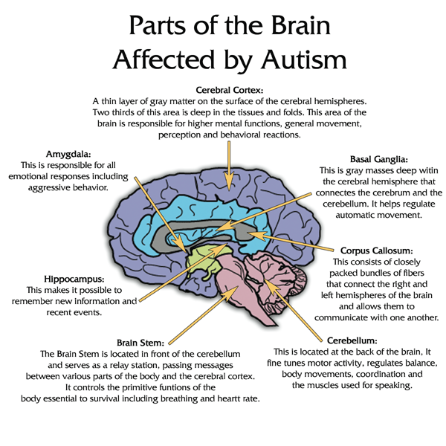
Figure 1: The diagram shows the parts of the human brain that are affected by autism (American Music Therapy Association, 2017).
As it can be seen, autism affects both the left and the right hemispheres of the brain. It is worth noting that music therapy also appeals to all these parts. Several mental disorders are grouped under the ASD category and can run from difficulties in social interaction, repetitive behaviors, and challenges in learning and problems in both verbal and non-verbal communication. Kern, Wolery, and Aldridge (2012) have recently established three core features that should be used to define whether a mental condition amounts to ASD. First, there should be impairments in social interaction. Secondly, there should be impairments in communication as well as language development. Finally, there should be the presence of repetitive and restrictive or stereotypic behaviors in the child (Kern, Wolery & Aldridge, 2012).
It should be noted that ASD diseases affect children during development and in some cases, the problems might last throughout the patient’s life. Studies have shown that there are no two children with autism are alike because the characteristics and symptoms presented depend on an individual and are indeed diverse and many. Moreover, it is worth noting that autism is not curable and in most cases, the child cannot outgrow the condition. Nevertheless, early diagnosis and intervention usually improve the child’s development and ability to cope with the challenges associated with the disease, thus enhancing the person’s quality of life (Okumura et al., 2014).
Studies have further shown that the prevalence of the disease is higher in the modern times than in the past. According to the centers for disease control and prevention, the incidence of the disease is likely to have increased to tenfold between 1500 and 2010. CDC reports that by 2010, about 1 in every 68 children have a form of autism and that males have nearly four times likelihood of developing the disease than girls (CDC, 2010). At the same time, CDC argues that the high prevalence of the disease in the modern times is probably due to improved diagnosis and increased awareness. It should be noted that each child with any member of the ASD diseases is unique and in most cases, some children have exceptional abilities such as in music, visual, academic, and other arts (Okumura et al., 2014). Autistic children often engage in several therapies necessary to assist them in overcoming the challenges that affect their mental, physical, and social development.

Music Therapy as an Intervention in Children with ASD
Music therapy began to find use in the medical field after the Second World War, primarily because of the observations made during the two world wars that traveling music groups were helping the traumatized and injured soldiers to recover quickly and efficiently. In the 1940s and 1950s, medical profession bodies were formed, primarily in Europe and the US, following the massive health problems that came with the effects of the war. For instance, the National Association of Music Therapy was formed in 1950 and, together with other societies in the US and the UK began advocating for holistic treatment philosophy. Among the interventions included in the comprehensive approach was music therapy and various publications were made to demonstrate its effectiveness in treating traumatized people as well as people with mental problems (Hillier, Greher, Poto & Dougherty, 2012). Between 1950 and 1970s, music therapists found increasing use in hospitals caring for traumatized and mentally sick people. In most cases, these professions were using such interventions as singing groups, rhythm activities, and fold dance to help maintain the healthy mental conditions (Hillier, Greher, Poto & Dougherty, 2012).
Towards the end of the 20th century, the idea to place children with autism into music classrooms gained popularity. Specifically, teaching staff, social workers, and some researchers had been reporting that children with autism have a unique interest in music. Moreover, there had been many researchers saying that autistic children had unusual ability to reproduce familiar pieces of music with a significant degree of precision (Hillier, Greher, Poto & Dougherty, 2012). From these experiences and observations, researchers developed the concept of musicality, which includes musical receptivity (the ability to perceive music) and musical creativity (the ability to reproduce and create music). Based on this concept, researchers found that autistic children could experience music as a medium of intervention and that they were more likely to become engaged than in other environments or settings.
From various studies, it can be deduced that music has a wide range of benefits to a person’s wellbeing, and autistic children can be managed with this approach. For instance, studies have shown that music evokes emotion, uplifts moods, reduces stress, and alleviates pain. Also, music engages various parts of the human brain (Hillier, Greher, Poto & Dougherty, 2012).
In autistic children, music therapy has been shown to work efficiently in helping them cope with the challenges associated with the condition. Two models have been used to produce evidence-based interventions in applying music therapy in ASD children- The Rational-Scientific Mediating Model (R-SMM) and the Transformational Design Model (TDM). In the R-SMM model, the method used in applying music therapy involves the connection between the response from an investigation of a given psychological, neurological and physical response to music and a similar reaction to the nonmusical stimulant. In this case, music perception is considered a mental response to musical stimulant (Hare, 2016).
According to American Music Therapy Association (2017), children with ASD tend to be visual learners, which means that information shared verbally is likely to be less efficient. Based on this information, researchers have developed an approach in which social stories are designed for delivering social information. Social stories are a combination of visual cues in which descriptive sentences have been added and are used to help the ASD children relate to their desired behaviors. The short story aims to allow sharing of information such as a concept or a description of an event, situation or an object.
According to the American Music Therapy Association (2017), music is a university language and serves to provide bridges in a non-threatening environment between individuals and their environment. Also, it enhances relationships and enables expression as well as communication. Secondly, the American Music Therapy Association (2017) states that music is effective in addressing the problems that autistic children face because it captures and maintains attention. According to this view, music is motivating as well as engaging and serves as a natural reinforcing factor for desired responses (Hare, 2016). When used, music therapy stimulates the people with mental problems or diseases to reduce self-stimulatory or adverse reactions while also increasing their level of participation in an appropriate and socially acceptable manner.
American Music Therapy Association (2017) shows that music therapy can enable the people with language problems to communicate and express themselves non-verbally. In most cases, music therapy includes assisting the development of verbal communication in autistic children (Staum, 2016). Also, music therapy improves the children’s communication, speech, and oral skills. The autistic children’s styles of communication are efficiently addressed by interpersonal timing and reciprocation in shared play, listening, responding and turn-taking, which is better achieved if augmented with music therapy. Moreover, American Music Therapy Association (2017) states that music therapy has an advantage of allowing individuals with autism spectrum to develop identification as well as the appropriate way of expressing their emotions.
It should be noted that music is processed in both the left and right hemispheres of the human brain. As such, it is possible that it can stimulate cognitive functioning and is useful in remediation of speech and language skills.
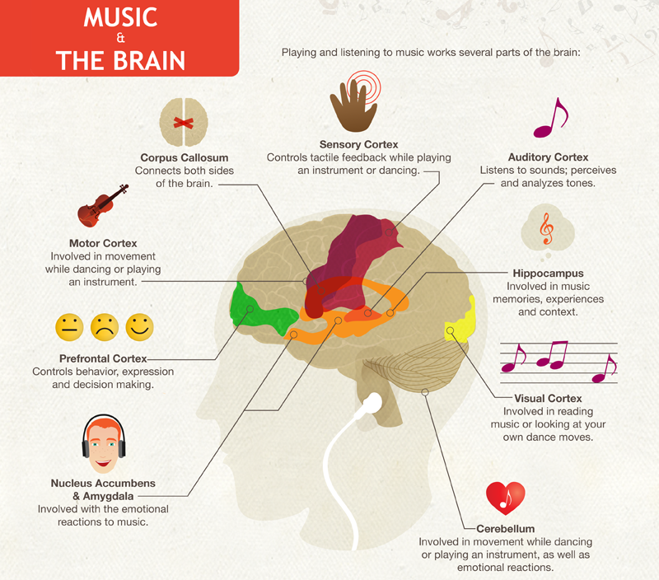
Figure 2: The relationship between music and the human brain (American Music Therapy Association, 2017).
The picture shows the several parts of the human brain and how music interacts with these regions. The American Music Therapy Association (2017) also shows that music provides concrete multi-sensory stimulations in the human brain, which includes visual, auditory, and tactile stimuli. In this case, the rhythmic aspect of music is useful in organizing the sensory systems of people living with autism. Consequently, auditory processing and sensory-motor, gross and fine motor, and perceptual motor are all enhanced when music therapy is applied.
Some studies have further shown that most people living with autism have an innate talent in music (Hare, 2016). Therefore, music therapy is likely to provide them with an opportunity to develop their abilities successfully. If they obtain these strengths, then it is possible to utilize them in addressing the child’s areas of need such as speech, communication, and language problems.

Music Therapy as a Career in the US

How it works
The United States is one of the developed nations that have considered music therapy as one of the interventions required in managing mental-related conditions and diseases in their national healthcare systems. In the country, music therapists are employed in schools, the healthcare system, social work, and professional psychiatric institutions. In these fields, the professional music therapists work with everyone, including the children with autism and other mental-related diseases, young people, adults, and the elderly. Apart from mental diseases, music therapists also play an important role in the management of substance abuse problems, brain injuries, physical disabilities and developmental disabilities. In their work, the professional music therapists use musical performance, songwriting, music lessons, and music listening as a way of providing therapy for medical intervention. The purpose of these activities is to ensure that they improve the patient’s emotional, cognitive, physical, and social abilities. Therefore, the professional music therapists are active in various institutions such as addiction recovery centers and rehabilitations, early childhood schools, elderly care homes, hospitals, and others. They always work as a team with other professionals such as teachers, nurses, doctors, physical and speech specialists, counsellors, psychiatrists, and client service directors.

Education and training
For an individual to take a career in music therapy, it is necessary to have the necessary education and training. Aspiring music therapists normally take courses in music, psychology, physiology, biology, social, and behavioral sciences. The music therapy bachelor’s degree program normally takes four years and students are required to complete 1200 hours of fieldwork, especially as an intern in an education or health-related institution. They are required to have at least a BA degree in their field. Advanced therapists must take an MA degree in the course and a doctoral degree is also necessary for those aspirin to provide care while also teaching music therapy students.

Salary and wages
The salary paid to music therapists in the US greatly depends on the individual institutions employing a person. Nevertheless, according to the US Bureau of Labor Statistics, the median annual salary for music therapists is roughly $39,607. The table below [provides a detailed description of the salary and employment opportunities for music therapists in the US.
Education | Bachelor's degree
Other Requirements | MT-BC certification
Expected Employment Growth (2014-2024) | 12% for all recreational therapists
Median Annual Salary (as of 2016) | $39,608
Figure 3. Education, employment, and salary details for US music therapists (U.S. Bureau of Labor Statistics, BLS, 2016)

Conclusion
From the research, it is evident that music therapy is a useful intervention tool for managing autism. Specifically, music therapy uses musical experiences as well as relationships that are achieved through them to enhance expression and communication. As such, it is useful as an intervention for addressing several core problems associated with ASD. When applied, music therapy is likely to increase communicative behaviors such as gestures, verbalization, vocalization, and comprehension of vocabularies. Nevertheless, few schools and hospitals consider applying this intervention in managing the condition. In fact, the knowledge obtained from the various studies on musical therapy is contained in books and not employed as an intervention. Consequently, my research is based on the finding that we have few individuals who have taken music therapy and are willing to apply it in their profession to address the problems facing the children with ASD. Therefore, I think this is an essential area for my career as I am gifted in music and at the same time I have the passion for working with autistic children.

References
American Music Therapy Association (2017). Music therapy and individuals with diagnoses on the autism spectrum. Retrieved from http://musictherapy.org/factsheets/MT%20Autism%202006.pdf
Brondino, N., Fusar-Poli, L., Rocchetti, M., Provenzani, U., Barale, F., & Politi, P. (2015). Complementary and alternative therapies for autism spectrum disorder. Evidence-Based Complementary and Alternative Medicine, 2015.
Geretsegger, M., Elefant, C., Mössler, K. A., & Gold, C. (2014). Music therapy for people with autism spectrum disorder. The Cochrane Library.
Hare, K. C. K. (2016). Autism spectrum disorders. The Handbook of Intellectual Disability and Clinical Psychology Practice, 467.
Hillier, A., Greher, G., Poto, N., & Dougherty, M. (2012). Positive outcomes following participation in a music intervention for adolescents and young adults on the autism spectrum. Psychology of Music, 40(2), 201-215.
Kern, P., Wolery, M., & Aldridge, D. (2012). Use of songs to promote independence in morning greeting routines for young children with autism. Journal of Autism and Developmental Disorders, 37, 1264-1271.
Okumura, Y., Asano, Y., Takenaka, S., Fukuyama, S., Yonezawa, S., Kasuya, Y., & Shinoda, J. (2014). Brain activation by music in patients in a vegetative or minimally conscious state following diffuse brain injury. Brain injury, 28(7), 944-950.
Staum, M. J. (2016). Music Therapy and Language for the Autistic Child. Retrieved from http://www.autism.org/musil.html
U.S. Bureau of Labor Statistics. (2017). Report on annual labor review 2016. Washington, DC: BLS

